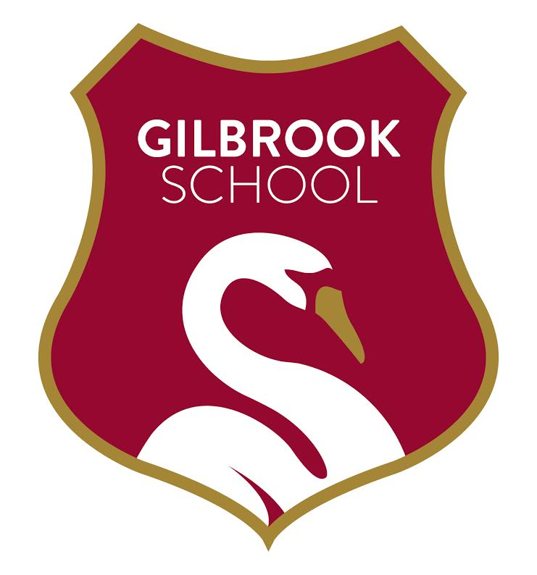

Monday 13th November 2023

We will be holding a ‘Christmas on the Farm day’ at Gilbrook on Friday 1st December.

We are raising money to buy our ducks a new house and are therefore asking for a donation of £2.50 from pupils who wish to take part in the experience.

All proceeds will go towards purchasing the new Duck House.

The day will start with breakfast (sausage batches) around the fire pit, later on we will be working with the animals; cleaning, feeding and general maintenance.

In the afternoon we will be hanging the Christmas decorations around the farm and fire pit area. We will finish the afternoon with hot chocolate, marshmallows and Christmas cookies.

We will send a paper copy of this letter home with a reply slip to return.

If you have any question please contact Mrs Moffittt.

Thank you for your continued support.

Mrs Moffitt & Mrs Carter

