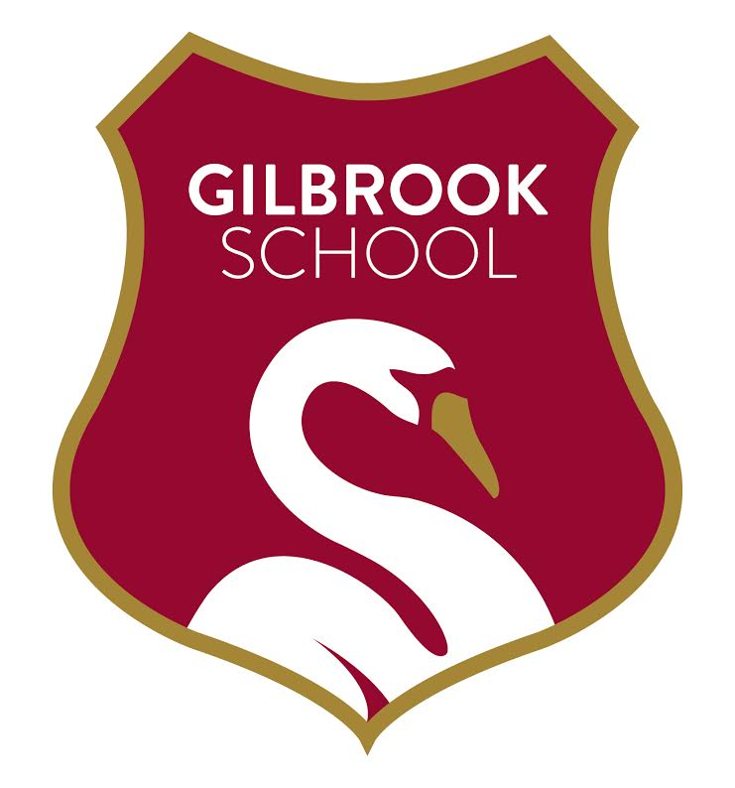

On Wednesday 15th November Merseyside police will be visiting the school as part of our PSHRE curriculum. They will be bringing with them two special guests from the mounted section.

We have to be conscious of allergy risks for staff and pupils. As such, we ask that you child comes into school with a clean uniform on Thursday to minimise any risk, we appreciate you co-operation in this matter.

If you have any issues with your child being with the horses please let us know immediately.

